Computer Language Coding Concepts

Value Assignment
About assignment in general: see the article Assignment.

Assigning the value of an object, means that the binary value stored inside one object is copied to another object. The binary value of the target object is overwritten.

About the notation of assignment in general, see the article Assignment in a Diagram.

An assignment is a call to an assignment command, but the expression of an assignment call is given a more basic notation, like this:

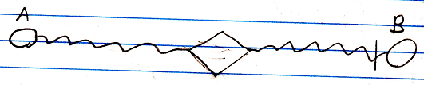

The fact, that the lines are wavy, expresses, that it is a value assignment. The access mark indicates the direction. The value of object A is assigned to object B.

See also: Assignment in a Diagram, Value Assignment

Author & Copyright: Jan-Joost van Zon Date: May 24, 2008 – July 24, 2008 Location: Oosterhout, The Netherlands Status: Finished

Ideas
Value Assignment,
2008-09-05

Actually, the notation will change. No call symbol will be visible, because a value connection is always a value assignment.

JJ

